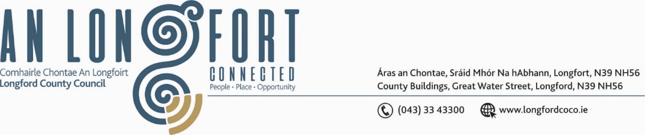

BALLYMAHON MUNICIPAL DISTRICT

Please note meeting will be held in Aras an Chontae and via Microsoft Teams.

22 June 2022

To: Each Member of Ballymahon Municipal District.

A Chomhairleoir,

You are requested to attend the Annual Meeting of Ballymahon Municipal District to be held in the Council Chamber, Aras an Chontae, Great Water Street, Longford and via Microsoft Teams on Wednesday, 29 June 2022 at 2pm to transact business, as set out on the Agenda hereunder.

Mise le meas,

Ann Marie Mc Keon
______________
Ann Marie Mc Keon,
Meetings Administrator.

C L A R

1. Election of Cathaoirleach.

2. Election of Leas Cathaoirleach.

3. Fix date and time of Ballymahon Municipal District meetings.



